***Documentation on Order to Cash Process in Power BI***

***Bindu Sai Sri Yerra***

**Page 1: Financial**

**Visualizations created in this:**

**Table: Sales and Receivable**

The table consists of Month and columns included:

Invoice Amount: Total amount of invoices generated during this month.

Receipt Amount: Total amount of cash received against those invoices.

Adjustment Amount: Adjustments made to the financial transactions during the month.

AR Balance: The Accounts Receivable balance calculated as the total invoice amount minus the total receipt amount minus the total adjustment amount.

Write-off Percentage: The percentage of Accounts Receivable adjustment compared to the total invoice amount, indicating the proportion of write-offs.

**Bar Chart:** **Bad Debts**

This bar graph displays the relationship between the amount of the invoice and the amount of the adjustment, offering insights into possible bad debts.

Each bar has a tooltip that gives you more details as added write-off %. This figure has been adjusted to show data for just the months of January 2020 through December 2020.

**QS1 Part 1 Objective Questions**

1. **What value would be recorded for total sales revenue on the income statement for 2020?**

**5,262,936.22**

1. **Which month recorded the highest sales revenue?**

**September – 488,672**

1. **What value would be recorded for total accounts receivable on the balance sheet for 2020, excluding the allowance for doubtful accounts?**

**4,030.532.79**

1. **If management estimates about 5 percent of sales to be written off each month, which month(s) exceeded that estimate?Feb – 0.06 – 6%**

**QS1 Part 1 Analysis Questions**

**AOQ 1. Why do you think there are no write-offs in November and December?**

To be written off, it must remain due for a specific amount of time. The bills are not immediately write-off by the business because the clients have only recently received them.

**AOQ 2. How could management estimate the write-offs for November and December?**

To Estimate the write-offs for November and December:

* **Historical Average:** The write-off percentage from previous months or the same months in previous years could be averaged by management to estimate the write-offs.
* **Aging Analysis:** Analyze the accounts receivable's age to determine the probability of non-payment, which could be utilized to calculate possible write-offs.
* **Research on Trends:** If the write-off percentages show a monthly trend, management may be able to predict future write-offs using this trend.
* **Economic Factors:** The ability of customers to pay their invoices can be impacted by changes in the business climate or external economic indices.
* **Provisioning Method:** Based on historical data and after accounting for any known modifications to the customer base or business environment, establish a provision for questionable debts.

**Page 2: Management**

**Visualizations created in this:**

**Table: Total Sales by Day**

It shows Total Sales Order amount by Sales Order Date.

**Bar Chart: Sales by Customer**

It shows Total Sales Order amount by Customer Account Name.

**Matrix Table: AR by Customer**

It shows AR balance for each customer with the invoices and age.

**Card: Days Sales Outstanding**

It shows the value of DSO which is key indicator of a company's efficiency in collecting receivables.

**QS1 Part 2 Objective Questions**

1. What are the total sales orders for November?

**416562.96**

1. Which day had the highest sales order amount in November?

**13th – 32660.64**

1. Which customer did the company sell the most to in November?

**Josue Haney**

1. How much did the company sell to that customer in November?

**6097.51**

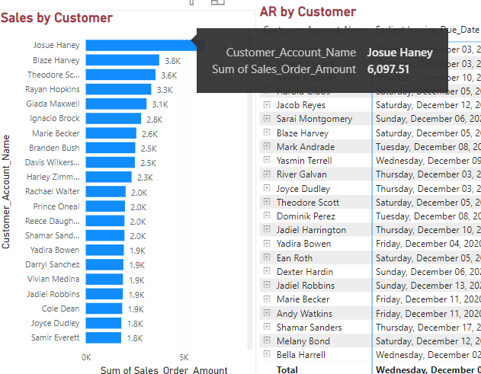

1. What is the value of the oldest outstanding invoice in November?

**1600.66**

1. What is the age of the oldest outstanding invoice?

**67**

1. What is the current days sales outstanding KPI value for 2020?

**26.52**

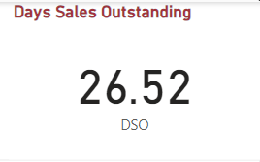

**QS1 Part 2 Analysis Questions**

1. **Why are some dates missing in the sales by date visualization?**The dates which are missing are the days which falls on weekends or holidays**.**
2. **Some of the accounts may have a negative age. Is this an error? What might explain this?**

If the "Report Date" is December 31, 2020, and the invoice has a January 1, 2021 due date, the age would be -1 day. This shows that as of the report date, the invoice was one day past due.

In this case, negative ages clearly indicate that the associated invoices were not paid by the deadlines. This useful measure can be used to determine past-due invoices and determine how much time has passed since the due date, giving valuable information about timely payments.

1. **What does the days sales outstanding KPI tell managers in general terms?**

Days Sales Outstanding (DSO) is a KPI that measures the average amount of time required by a business to obtain payment following a sale. Managers can use these statistics to assess how well the company's credit and collection policies and procedures are working. It generally informs management of the speed at which customers are paying their bills.

* A lower DSO means that the company is collecting payments more quickly, which can lead to better cash flow management.
* High DSO might signal that a company's credit policies are too lax, allowing customers to delay payments.
* A rising DSO may suggest a trend of customers taking longer to pay, which could require additional attention to credit and collections practices.

1. **What risks are present if you take too long to collect accounts receivable?**Taking too long to collect accounts receivable can pose several risks to a business, including:

* **Cash Flow Problems:** Prolonged collection times can generate serious cash flow problems for the company, as it may not have enough cash on hand to pay for operating costs including payroll, rent, utilities, and supplier payments.
* **Rising Bad Debt Cost:** The likelihood that an account receivable will become uncollectible increases with its outstanding duration. This could have a detrimental effect on the bottom line by raising bad debt costs and write-offs.
* **Opportunity costs:** Funds reserved for accounts receivable prevent cash from being used for other purposes, such debt repayment, capital return to shareholders, or growth possibilities investments.
* **Creditworthiness:** Lenders and suppliers may consider a business to have poor creditworthiness if its DSO is consistently high. This might lead to less advantageous lending arrangements, including longer payment durations or higher interest rates, which would exacerbate cash flow issues even further.
* **Financial Ratio Impact:** Some financial ratios, such the current ratio and the quick ratio, are impacted by high accounts receivable levels. These ratios are used to evaluate the performance and stability of the organization. Lenders and investors may find the company less appealing as a result.

**Page 3: Audit**

**Visualizations created in this:**

**Table: Exceptions**

It shows the shipments that occurred before the order was placed.

**Table: Missing Invoice**

It shows the shipped orders but the invoice haven’t generated.

**QS1 Part 3 Objective Questions**

1. Which orders were created after shipment?

**3 Orders created after shipment.**

1. How many orders have been shipped but not yet invoiced?

**One missing Invoice**

**QS1 Part 3 Analysis Questions**

1. **What types of controls would prevent the system from skipping a process or step?**

To ensure that the system doesn't skip processes or steps in the order-to-cash (O2C) cycle, a variety of controls can be instituted:

* **Segregation of Duties:** Assign different people to oversee various O2C process steps. By having numerous individuals to execute tasks, this lowers the possibility of fraud or errors.
* **Authorization controls**: Require authorization at different stages of the O2C process, like price and terms approval, sign-off prior to invoice delivery, and credit approval prior to order release.
* **Automated Workflow Systems:** Make use of an automated system that outlines every stage in the O2C process and necessitates finishing each one before going on to the next. By doing this, it can be ensured that no steps are missing.
* **Procedures for Reconciliation:** Daily basis, reconcile cash received with invoices to make sure that payments are allocated to outstanding receivables in a timely and accurate manner.
* **Credit controls:** Credit limitations are set, and customers' creditworthiness is systematically evaluated. Examine credit limits on a regular basis considering payment history and other financial metrics.
* **Regular Reviews and Audits:** Conduct recurring reviews and audits of the O2C process, either internally or externally. This might assist in locating any variations from the set protocols.
* **SOP - Standard Operating Procedures:** Ensure that the O2C cycle has comprehensive, documented SOPs, and that personnel are trained in these procedures. Make frequent updates to these documents to match modern procedures.
* **Quality Control Checks:** To guarantee correctness and completeness, conduct quality control checks at crucial stages, such as following order entry or before to invoice issuing.